Git Training
Git

Git
What is Git? 2
Remote repositories and local repositories 3
Install Git 3
On Windows 3
On MacOS 4
Git workflow 5
Step 1: Git clone 5
What is branches? 7
Step 2: Create a new branch and switch to the new branch 8
Step 3: Add and commit file(s) 9
Step 4: Push branch to Remote repository 10
Step 5: Fix comments 10
Step 6: Merge branch 11
Step 7: Pull remote branch 13
Fix conflicts 14

What is Git?
Git is a popular version control system. It was created by Linus Torvalds in 2005, and has been maintained by Junio Hamano since then.
It is used for:
- Tracking code changes
- Tracking who made changes
- Coding collaboration

Remote repositories and local repositories
- A remote repository is hosted on a remote, or off-site, server that is shared among multiple team members. Example: Github, Gitlab, Bitbucket
- A local repository is hosted on a local machine for an individual user.
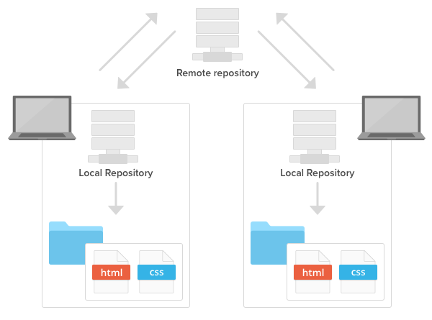

Install Git

On Windows
- Download the latest Git for Windows installer.
- When you've successfully started the installer, you should see the Git Setup wizard screen. Follow the Next and Finish prompts to complete the installation. The default options are pretty sensible for most users.
- Open a Command Prompt (or Windows Terminal or Git Bash if during installation you elected not to use Git from the Windows Command Prompt).
$ git --version

On MacOS
- Git for Mac Installer
The easiest way to install Git on a Mac is via the stand-alone installer:
  - Download the latest Git for Mac installer.
  - Follow the prompts to install Git.
  - Open a terminal and verify the installation was successful by typing git --version:
$ git --version
- Install Git with Homebrew
If you have installed Homebrew to manage packages on OS X, you can follow these instructions to install Git:
Open your terminal and install Git using Homebrew:
$ brew install git
Verify the installation was successful by typing which git --version:
$ git --version

Git workflow
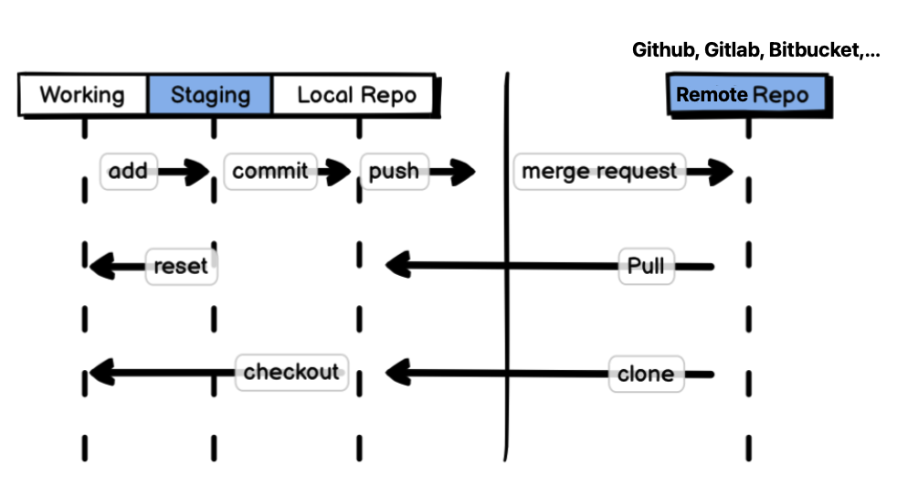
There are three main components of a Git project:
- Repository
- Working tree
- Index
The repository, or local repo, is the “container” that tracks the changes to your project files. It holds all of the commits — a snapshot of all your files at a point in time — that have been made. You can access the commit history with the Git log.
The working tree, or working directory, consists of files that you are currently working on. You can think of a working tree as a file system where you can view and modify files.
The index, or staging area, is where commits are prepared. The index compares the files in the working tree to the files in the repo. When you make a change in the working tree, the index marks the file as modified before it is committed.

Step 1: Git clone
You can copy a remote repository onto your local machine using the git clone command. By default, git clone will automatically set up a local master branch that tracks the remote master branch it was cloned from.
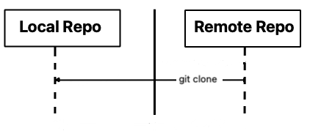
Example: Clone automation-test-framework project from Bitbucket
- Access automation-test-framework project in Bitbucket via url https://github.com/Tuyendk4/VTI_AT-20230524
- Click Code on the website
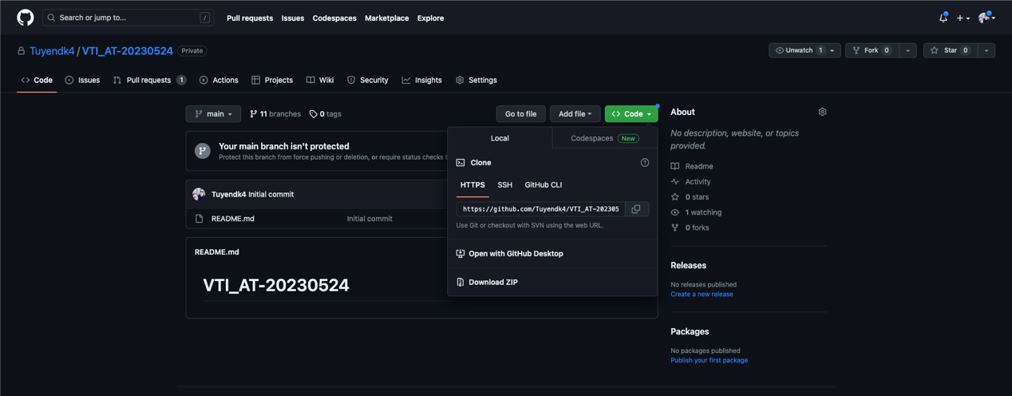
- Click Copy icon to copy the link
- Open iTerm (on MacOS) or Windows Terminal (on Windows) and paste the command
$ git clone https://github.com/Tuyendk4/VTI_AT-20230524
Before open iTerm or Windows Terminal, pls create a folder to store the project, i.e. training-workspace
After open iTerm or Windows Terminal, pls use cd command to move to training-workspace folder
You will see VTI_AT-20230524 in training-workspace folder after git clone ran successfully
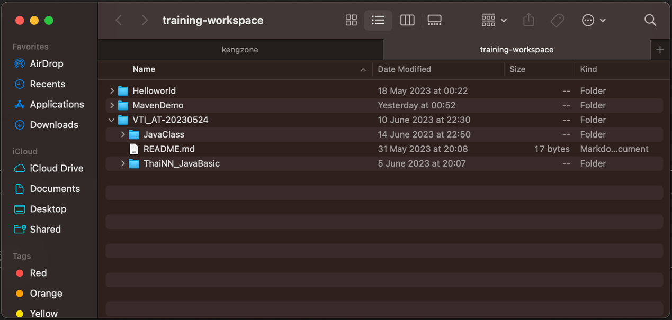
pls use cd command to move to training-workspace folder in iTerm or Windows Terminal
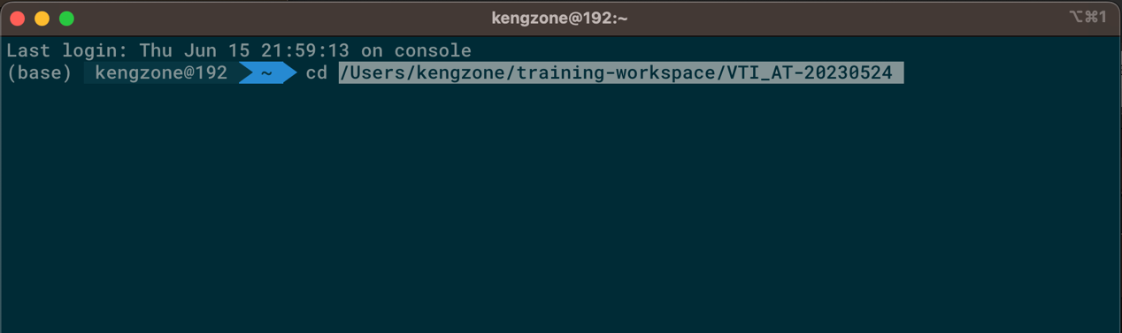
You will see master brand in iTerm or Windows Terminal
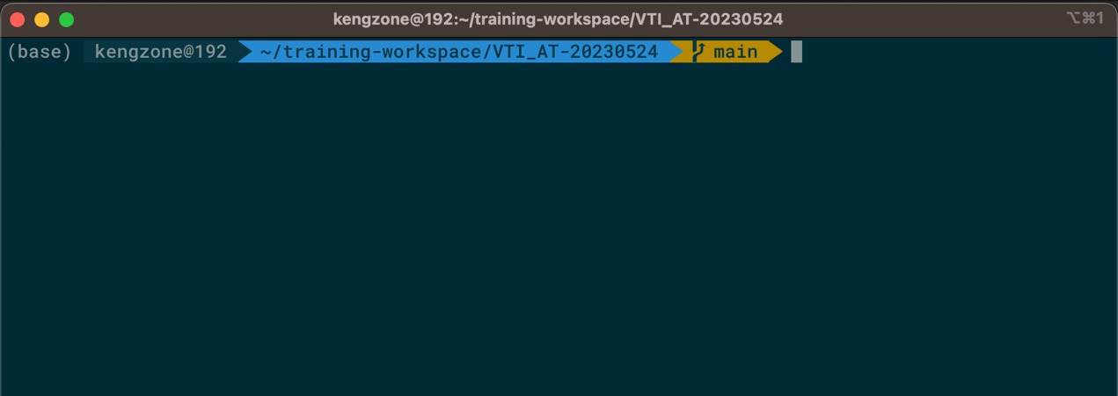

What is branches?
In a collaborative environment, it is common for several developers to share and work on the same source code. While some developers will be fixing bugs, others will be implementing new features, etc. With so much going on, there needs to be a system in place for managing different versions of the same code base.
Branching allows each developer to branch out from the original code base and isolate their work from others. It also helps Git to easily merge versions later on.
master/main branch is default branch.

Step 2: Create a new branch and switch to the new branch
Pls understand that create a new branch means create a new working area. To create a new branch, you use command: git branch <branch name>
Example: create a new branch with name write_breakstack_crm_test_scripts
$ git branch git_demo
Now, you created a new branch successfully. You use git checkout <branch name> to switch the new branch
$ git checkout git_demo

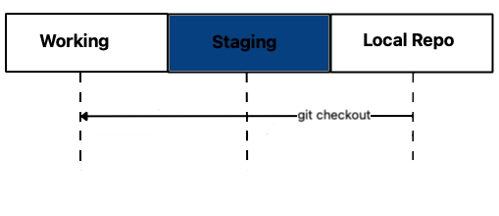
You can use one command to create a new branch and switch to the new branch by command git checkout -b <branch name>
$ git checkout -b git_demo

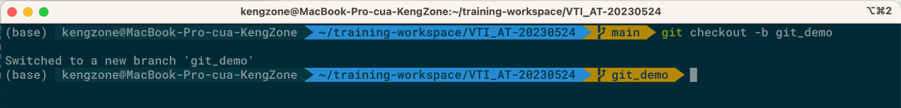
You only use command git checkout -b <branch name> if the <branch name> does not existed on Git.
If you want to switch existed branches, you only use: git checkout <branch name>

Step 3: Add and commit file(s)
The git add command adds a change in the working directory to the staging area. It tells Git that you want to include updates to a particular file in the next commit. However, git add doesn't really affect the repository in any significant way—changes are not actually recorded until you run git commit.
Syntax: For one file, pls use git add <file name>
For one or many files, pls use git add -A RECOMMEND
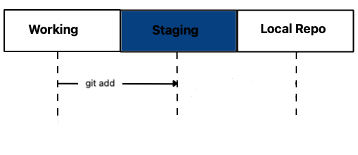
The git commit command lets you record file changes in the repository's Git history.
Every change you commit will be viewable in the respective file or directory in chronological order.
Syntax: git commit -m <commit message>
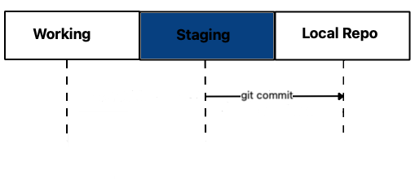

$ git commit -m "Git demo"

Step 4: Push branch to Remote repository
All of your commits are available to you until you push your local branch to the remote repository. That is, you can work on your own local branch at your own pace without affecting other members of the team.
When you push your local branch to remote, Git will do a fast-forward merge to the destination repository.
However, if the push results in a non-fast-forward merge, Git will decline your push to prevent you from overwriting previous commits. In that case, you have to pull the latest remote changes and push again.
Syntax: git push origin <branch name>
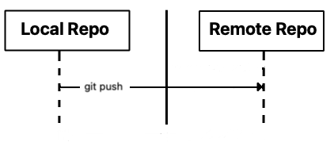

$ git push origin git_demo

Step 5: Fix comments
Senior automation tester or Leader reviews and comments code of members on new pushed branch.
Member fix comments and do below steps to push new code to the remote branch:
$ git add -A
$ git commit --amend
$ Press 'i' key
$ Press 'Esc' key
$ Input ':wq!'
$ git push origin <your_branch> -f
Command git commit --amend: edit commit message. If you use the command, terminal will switch to text mode
Press 'i' key: switch to Insert mode to edit commit message
Press ‘Esc’ key (MacOS) or CTRL + SHIFT + SPACE (Windows): exit Insert mode
Input ‘:wq!’: save commit message and force quit text mode
git push origin git_demo -f : You must add -f at the end of command because the branch is existed on remote repository, and you want to update files to remote repository in the branch

Step 6: Merge branch
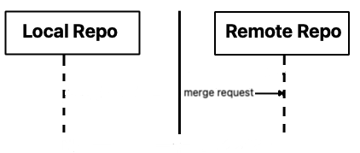
Only Senior Automation or Leader merge branches
On Remote Repository (Bitbucket), we have 2 main branches (master/main, dev). We only merge new branch to dev branch on remote repository.
Access the url https://github.com/Tuyendk4/VTI_AT-20230524 , then click Pull requests tab
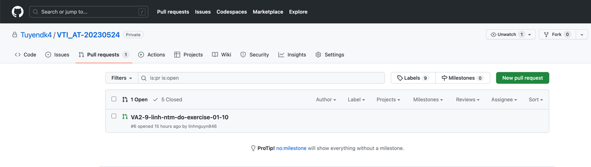
Then click New pull request
Select source branch that you want to merge it
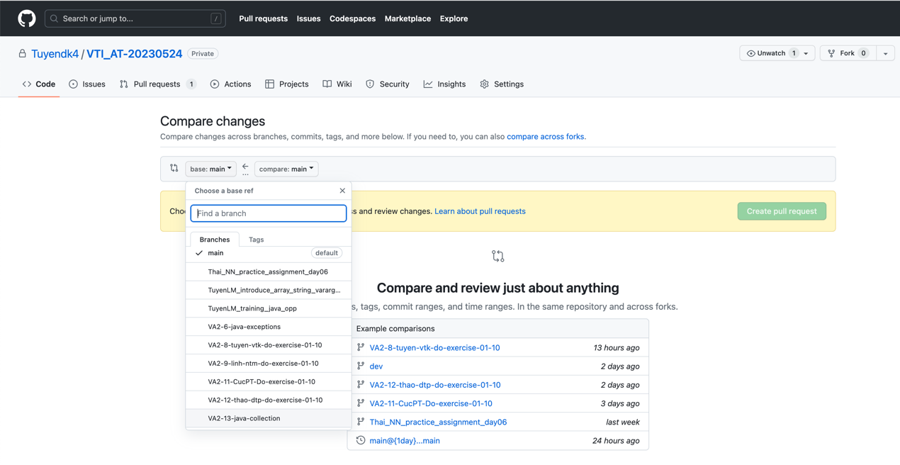
Select dev branch is destination branch
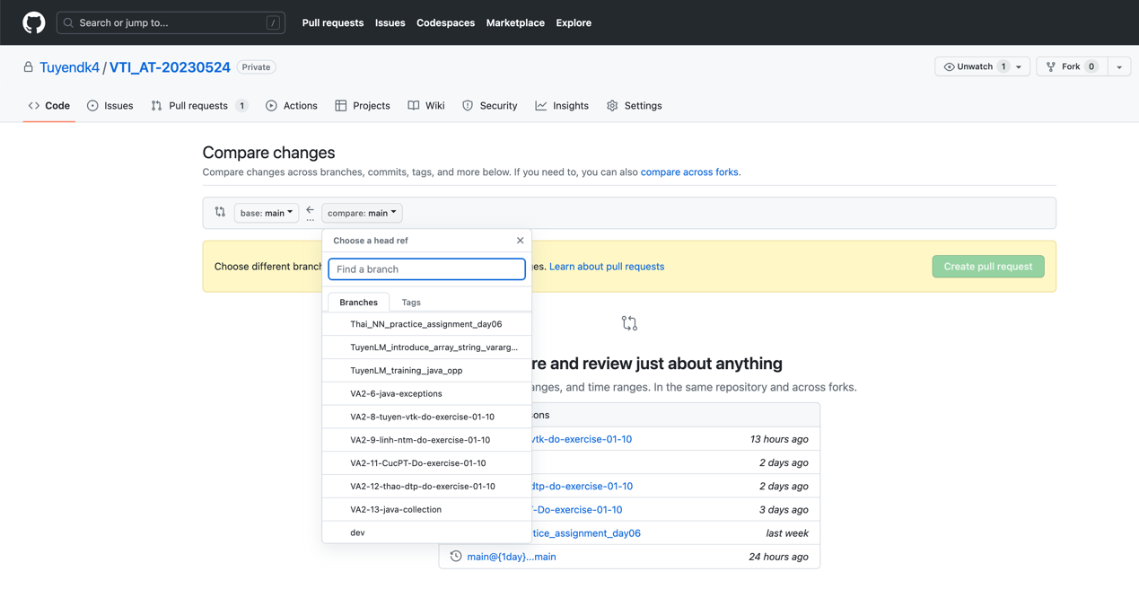
Click Create pull request button
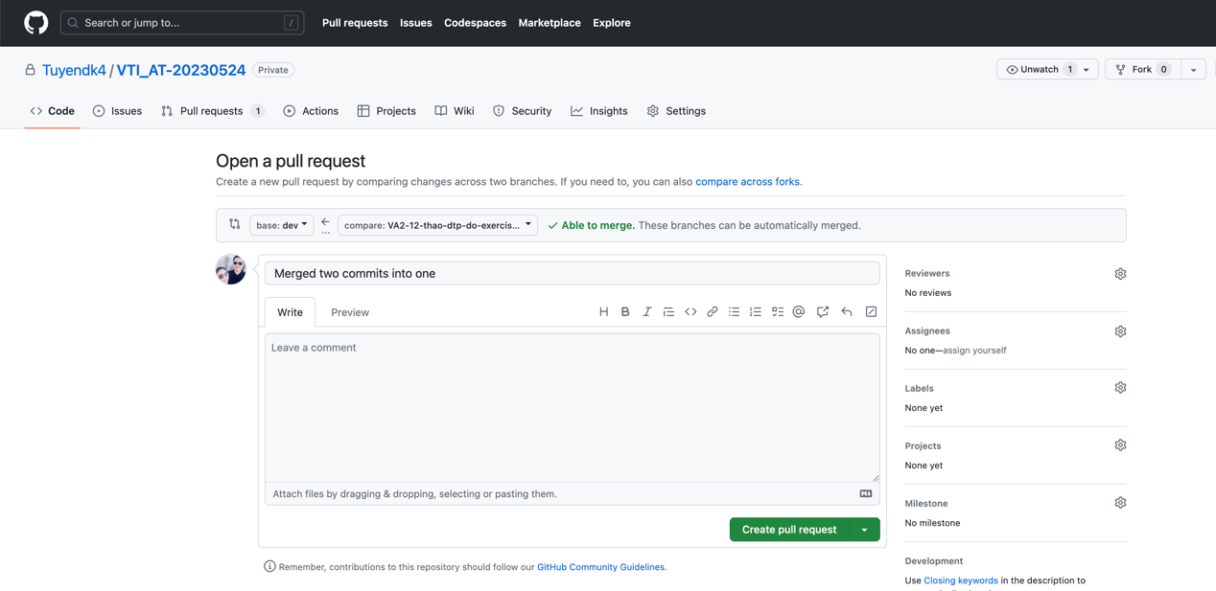
Click Merge pull request button (only use by Leader)

Step 7: Pull remote branch
All commits (new branches) are merged to dev branch. So you need to create dev branch on local repository via command
$ git checkout -b dev
The command is used only one time. Next time, you only use below command:
$ git checkout dev
pls use bellow command to update changes from dev branch (remote repository) to dev branch (local repository)
$ git pull origin dev

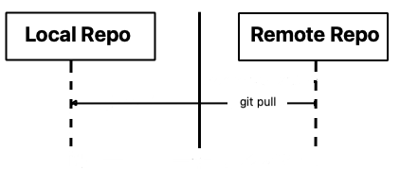
For new task, you have to create new branch from dev branch as below image:
$ git checkout -b <new branch name>
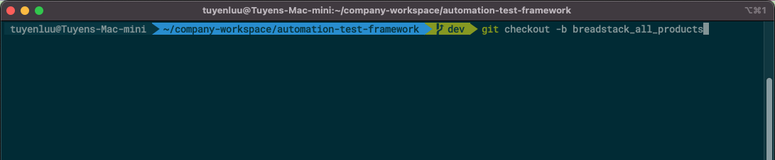
Repeat Step 3 to Step 7 for new task

Fix conflicts
Actually, member work with many files in a branch, so the project has one or many files which members work with them together in their local branch. If one branch of one of members is merged to dev branch on remote repository, other members must update new changes from dev branch on remote repository to dev branch on their local repository and fix conflicts as below steps:
For no change on your branch
$ git checkout dev
$ git pull origin dev
$ git checkout <your_working_branch>
$ git rebase dev
git rebase: Rebasing is the process of moving or combining a sequence of commits to a new base commit. Rebasing is most useful and easily visualized in the context of a feature branching workflow.
After the command git rebase dev, if appear conflicts, you can see CONFLICT in your terminal as below image
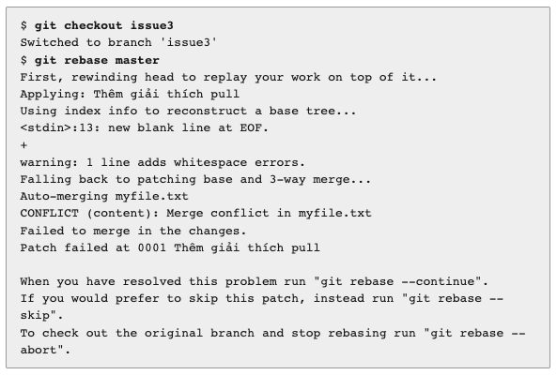
You must fix the conflicts. Open the file which has a conflict
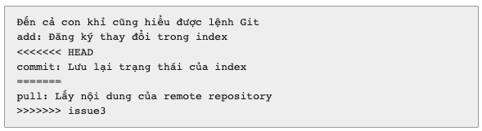
<<<<<<< HEAD
commit: Lưu lại trạng thái của index
=======
The above change belongs to old commit that is merged to dev branch
=======
pull: Lấy nội dung của remote repository
>>>>>>> issue3
The above change belongs to new commit on your local repository that don’t merge to dev branch on remote repository
Case 1: If you want to keep change of two commit, you remove <<<<<<< HEAD, =======, >>>>>>> issue3
Đến cả con khỉ cũng hiểu được lệnh Git
add: Đăng ký thay đổi trong index
commit: Lưu lại trạng thái của index
pull: Lấy nội dung của remote repository
Case 2: If you want to keep your change, you remove old commit and >>>>>>> issue3
Đến cả con khỉ cũng hiểu được lệnh Git
add: Đăng ký thay đổi trong index
pull: Lấy nội dung của remote repository
You should not remove old commit, only merge your changes => Case 2 only for Senior automation or Leader
After finished to fix all conflicts, pls use below commands
$ git add -A
$ git rebase --continue
$ git commit --amend
$ Press 'i' key
$ Press 'Esc' key // Press CTRL + SHIFT + SPACE (on Windows)
$ Input ':wq!'
$ git push origin <your_working_branch> -f
For having some changes on your branch
$ git stash save
$ git checkout dev
$ git pull origin dev
$ git checkout <your_working_branch>
$ git rebase dev
$ Fix conflicts
$ git add -A
$ git rebase --continue
$ git commint --amend
$ Press 'i' key
$ Press 'Esc' key // Press CTRL + SHIFT + SPACE (on Windows)
$ Input ':wq!'
$ git push origin <your_working_branch> -f

